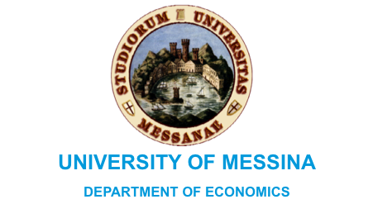
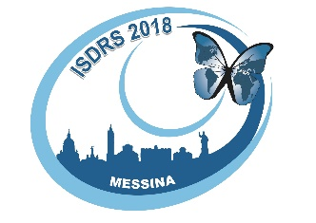

PRESS RELEASE

The 24th International Sustainable Development Research Society Conference, from June 13th to 15th , 2018

An international event on the future of Sustainability: experts to meet in Messina

Professor Salomone: “The International ISDRS Congress is meeting for the first time in Italy and Messina”

Messina, May, 29^{th.} The 24th International Sustainable Development Research Society Conference (ISDRS) will be held at the University of Messina, in Italy, from the 13th to 15th of June. ISDRS is a global network, consisting of more than 1200 researchers and specialists in the area of sustainable development, who work in all continents. Their aim is to maximise cooperation and an exchange of knowledge, experience and best practice in order to obtain an equal, sustainable and cleaner society.
The City of Messina will host the event which is a very important opportunity for both the City and the University of Messina to demonstrate their ability to organize an important international conference.
The congress was organized by the academics of the faculty “Commodity Science” of the Department of Economics and coordinated by Professor Roberta Salomone. The participants will get a chance to focus on the way scientists and researchers are developing methods and theories on sustainable development. It will also be interesting to understand how policy makers, public and private organizations, advisers and specialists as well as citizens, can put this knowledge into practice. An important part of the conference will be to analyse whether the implementation of new technologies can guarantee the achievement of international objectives, such as those defined by the United Nations 2030 Sustainable Development Agenda.
300 participants are expected, coming from all over the world; they will present their research over three days, organized in 31 different themes and tracks. There will be a pre-conference event, the 12th Italian LCA Network Conference (June 11th-12th) and a workshop (June 12th) reserved for PhD students who are working on sustainable themes.
The congress experience will end with the delegates’ participation in “sustainability tours” on June 16th, visiting some of the most beautiful natural places in the province of Messina.
But that is not all: the conference has been organized according to a sustainable policy, which will be disclosed during the press conference of June 5^{th,} 2018, at 10.30 am, in the Senate Room of the University of Messina. As Professor Roberta Salomone, coordinator of the organizing committee, pointed out: “Hosting an international event like this, for the first time in Italy, represents a special occasion to promote and spread the importance of acting in a sustainable way. Lots of local organizations and others have believed in our project and they have decided to contribute to the success of this project.”

For more information:
Contact the Department of Economics, University of Messina,
Email: isdrs2018@unime.it

